Project Title | BankSight: Transaction Intelligence Dashboard
Skills take away From This Project | Python, SQL, Streamlit, Data Analysis, Financial Analytics
Domain | Banking, Finance, Customer Behavior Analysis, Fraud Prevention
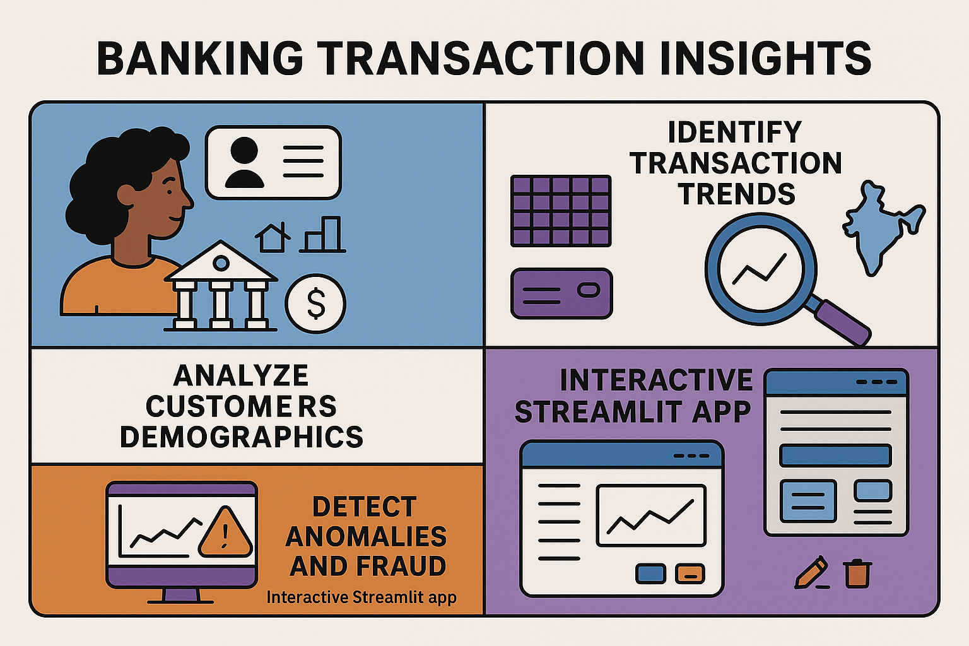

Problem Statement
Banks process millions of transactions daily, with critical needs to understand customer behavior, transaction patterns, and detect fraudulent activity early. This project aims to develop a Banking Transaction Insights system to:
- Analyze customer demographics linked to bank accounts and transaction activity.
- Identify transaction trends across account types, branches, and regions.
- Detect anomalies and potentially fraudulent transactions.
- Provide an interactive Streamlit app to explore transaction data with filters and CRUD operations on accounts and transactions.

Business Use Cases
- Profiling customer transaction behavior to tailor banking products.
- Identifying high-risk transactions and accounts for fraud prevention.
- Branch performance evaluation based on transactions and accounts.
- Enabling customers and bank officials to query transaction histories interactively.

Approach

. Data Preparation
- Load and clean the datasets: customers, accounts, and transactions, etc.
- Ensure data consistency, remove duplicates, and validate foreign key relationships.

2. Database Creation
- Create SQL tables for Customers, Accounts, and Transactions datasets.
- Implement CRUD operations to manage account and transaction data.

3. Data Analysis
- Use SQL queries to extract insights such as transaction volume by city, account type, transaction type, and customer demographics.
- Detects unusual transaction patterns that may indicate fraud.

4. Application Development
- Build a Streamlit app to:
  - Display outputs of 15+ SQL queries with results visualization.
  - Provide filters for date range, city, account type, transaction type, transaction amount, and gender.
  - Allow CRUD operations for accounts and transactions management.

5. Deployment
- Deploy the Streamlit app for use by banking analysts and customer support teams.

Data Flow and Architecture

Data Storage
- SQL database storing customers, accounts, and transactions tables with relationships.

Processing Pipeline
- SQL queries and Python scripts for data analysis and anomaly detection.

Deployment
- Streamlit front-end interfacing with the SQL database to display data and insights interactively.

Dataset:

Customers Dataset: customers.csv

Account Balances Dataset: accounts.csv

Transactions Dataset: transactions.csv

Loans Dataset: loans.json / loans.csv

Credit Cards Dataset: credit_cards.json

Branches Dataset: branches.json / branches.csv
- Support Tickets Dataset: support_tickets.json / support_tickets.csv
Dataset Explanation:

1. Customers Dataset: customers.csv
Contains core demographic details and primary account type for bank customers.
- customer_id (Alphanumeric String) – Unique identifier for each bank customer.
- name (String) – The full name of the customer.
- gender (String) – The customer's gender (e.g., M, F).
- age (Integer) – The age of the customer.
- city (String) – The city of residence for the customer.
- account_type (String) – The type of the customer's primary account (e.g., Savings, Current).
- join_date (Date) – The date the customer joined the bank.

2. Account Balances Dataset: accounts.csv
Contains the latest account balance information linked to each customer.
- customer_id (Alphanumeric String) – Linked customer identifier.
- account_balance (Float) – The current total balance held by the customer.
- last_updated (DateTime) – The date and time when the account balance was last updated.

3. Transactions Dataset: transactions.csv
Contains a detailed log of all transactions conducted by customers.
- txn_id (Alphanumeric String) – Unique identifier for each transaction.
- customer_id (Alphanumeric String) – Linked customer identifier who performed the transaction.
- txn_type (String) – The nature of the transaction (e.g., deposit, withdrawal, transfer, online fraud, purchase).
- amount (Float) – The monetary amount involved in the transaction.
- txn_time (DateTime) – The exact date and time the transaction occurred.
- status (String) – The final outcome of the transaction (e.g., success, failed).

4. Loans Dataset: loans.json
Contains details for various types of loans issued by the bank.
- Loan_ID (Integer) – Unique identifier for each loan.
- Customer_ID (Integer) – Linked customer identifier.
- Account_ID (Integer) – Linked account identifier.
- Branch (String) – The branch responsible for managing the loan.
- Loan_Type (String) – The category of the loan (e.g., Personal, Business, Home, Auto).
- Loan_Amount (Integer) – The principal amount of the loan.
- Interest_Rate (Float) – The annual interest rate applied to the loan.
- Loan_Term_Months (Integer) – The duration of the loan agreement, in months.
- Start_Date (Date) – The date the loan was initiated.
- End_Date (Date) – The scheduled date for the loan to be fully repaid.
- Loan_Status (String) – The current operational status of the loan (e.g., Active, Closed, Approved).

5. Credit Cards Dataset: credit_cards.json
Contains details for all credit cards associated with bank accounts.
- Card_ID (Integer) – Unique identifier for each credit card.
- Customer_ID (Integer) – Linked customer identifier.
- Account_ID (Integer) – Linked account identifier.
- Branch (String) – The branch managing the credit card.
- Card_Number (String) – The credit card number (as a string).
- Card_Type (String) – The tier or type of the card (e.g., Business, Platinum, Gold, Silver).
- Card_Network (String) – The payment network (e.g., Visa, RuPay, Amex, MasterCard).
- Credit_Limit (Integer) – The maximum spending limit on the card.
- Current_Balance (Float) – The current outstanding balance/debt on the card.
- Issued_Date (Date) – The date the card was issued.
- Expiry_Date (Date) – The date the card is set to expire.
- Status (String) – The current operational status of the card (e.g., Active, Expired, Blocked).

6. Branches Dataset: branches.json
Contains detailed information about each of the bank's branches.
- Branch_ID (Integer) – Unique identifier for the bank branch.
- Branch_Name (String) – The full name of the branch.
- City (String) – The city where the branch is physically located.
- Manager_Name (String) – The name of the manager overseeing the branch.
- Total_Employees (Integer) – The number of employees working at the branch.
- Branch_Revenue (Float) – The total revenue generated by the branch.
- Opening_Date (Date) – The date the branch commenced operations.
- Performance_Rating (Integer) – A rating (1-5) indicating the branch's performance.

7. Support Tickets Dataset: support_tickets.json
Contains records of all customer service interactions, including the issue details, resolution status, and customer feedback.
- Ticket_ID (Alphanumeric String) – Unique identifier for each support ticket.
- Customer_ID (Alphanumeric String) – Linked customer identifier.
- Account_ID (Alphanumeric String) – Linked account identifier.
- Loan_ID (Integer/String) – Linked loan identifier (may be empty if the ticket is not loan-related).
- Branch_Name (String) – The bank branch associated with the ticket or customer.
- Issue_Category (String) – The type of problem reported (e.g., Loan Payment Delay, Card Not Working, EMI Auto-debit Failed).
- Description (String) – A short summary of the issue raised by the client.
- Date_Opened (Date) – The date the support ticket was created.
- Date_Closed (Date) – The date the ticket was resolved or closed.
- Priority (String) – The urgency level of the ticket (e.g., Critical, Low).
- Status (String) – The current state of the ticket (e.g., Resolved, Closed, In Progress).
- Resolution_Remarks (String) – Detailed notes on the solution provided.
- Support_Agent (String) – The name of the agent who handled the ticket.
- Channel (String) – The method of communication (e.g., Email, Phone, In-person).
- Customer_Rating (Integer) – The customer's satisfaction rating for the support service (e.g., 1-5).

Questions to be Answered (SQL Queries & Analysis)

1️⃣ CUSTOMER & ACCOUNT ANALYSIS
- Q1: How many customers exist per city, and what is their average account balance?
- Q2: Which account type (Savings, Current, Loan, etc.) holds the highest total balance?
- Q3: Who are the top 10 customers by total account balance across all account types?
- Q4: Which customers opened accounts in 2023 with a balance above ₹1,00,000?

2️⃣ TRANSACTION BEHAVIOR
- Q5: What is the total transaction volume (sum of amounts) by transaction type?
- Q6: How many failed transactions occurred for each transaction type?
- Q7: What is the total number of transactions per transaction type?
- Q8: Which accounts have 5 or more high-value transactions above ₹20,000?
3️⃣ LOAN INSIGHTS
- Q9: What is the average loan amount and interest rate by loan type (Personal, Auto, Home, etc.)?
- Q10: Which customers currently hold more than one active or approved loan?
- Q11: Who are the top 5 customers with the highest outstanding (non-closed) loan amounts?

4️⃣ BRANCH & PERFORMANCE
- Q12: What is the average loan amount per branch?
- Q13: How many customers exist in each age group (e.g., 18–25, 26–35, etc.)?

5️⃣ SUPPORT TICKETS & CUSTOMER EXPERIENCE
- Q14: Which issue categories have the longest average resolution time?
- Q15: Which support agents have resolved the most critical tickets with high customer ratings (≥4)?
Results

A Streamlit Application that:
- Displays all 6 core datasets interactively:
  - Customers, Accounts, Transactions, Branches, Loans, and Support Tickets
  - Tables can be viewed directly from the database in the “📊 View Tables” section.
- Provides powerful multi-level filtering:
  - In the “🔍 Filter Data” page, users can:
    - Select any dataset
    - Choose one or more columns to filter
    - Apply multiple filters simultaneously
    - Instantly view the filtered data from SQLite3 database
- Includes complete CRUD functionality:
  - In the “✏️ CRUD Operations” section, users can:
    - Create, Read, Update, and Delete records from any table
    - Changes reflect directly in the SQLite database in real-time
    - User-friendly input fields for every column
- Simulates real banking operations (Credit/Debit):
  - In the “💰 Credit / Debit Simulation” page:
    - Enter an Account ID to check current balance
    - Perform Deposit or Withdraw operations
    - System enforces a minimum ₹1000 balance rule
    - Automatically updates the account’s balance in the database
- Presents 15+ analytical SQL insights:
  - In the “🧠 Analytical Insights” page:
    - Users select from a dropdown of 15 real-world banking questions
    - Each query executes live against the SQLite database
    - Results are displayed in tabular format with query text for transparency
    - Covers domains like transactions, loans, fraud detection, and performance
- Displays project and creator information:
  - “🏠 Introduction” page describes the purpose, objectives, and datasets
  - “👩‍💻 About Creator” page includes your details (photo, name, expertise, and contact info)
Project Evaluation Metrics:
- Completeness and integrity of SQL database with all datasets linked properly.
- Accuracy and efficiency of SQL queries in providing meaningful banking insights.
- Functionality and usability of CRUD operations.
- User experience of the Streamlit interface with filtering and visualization.
- Ability to detect anomalies and flag potential fraud cases.

Technical Tags:
Python, SQL, Streamlit, Data Analysis, Banking Analytics, Fraud Detection
Deliverables:
- Data Preparation and Cleaning scripts for all three datasets.
- SQL database creation scripts and schema.
- 15+ SQL queries with detailed explanations.
- Streamlit app code including filters, CRUD, and data visualization.
- Documentation and user guide for app usage and deployment.

Timeline:
- 1 Week
References:

Project Live Evaluation Metrics | Project Live Evaluation
EDA Guide | Exploratory Data Analysis (EDA) Guide
Capstone Explanation Guideline | Capstone Explanation Guideline
GitHub Reference | How to Use GitHub.pptx
Streamlit recordings (English) | Special session for STREAMLIT(11/08/2024)
STREAMLIT RECORDING (Tamil) | Streamlit - Tamil
Streamlit documentation | Install Streamlit  Streamlit App on Streamlit Cloud  str_app.py
HOW TO ESTABLISH SQL CONNECTION: | PYTHONSQLCODE_TAMIL.ipynb
Project Excellence Series (English) | Project Excellence Series: Guided Learning & Problem Solving [Python & SQL](English)
Project Excellence Series (Tamil) | Project Excellence Series: Guided Learning & Problem Solving [Python & SQL](Tamil)
Project Orientation (English) | Project Orientation Session : BankSight: Transaction Intelligence Dashboard (English)
Project Orientation (Hindi) | Project Orientation Session : BankSight: Transaction Intelligence Dashboard (Hindi)
Project Orientation (Tamil) | https://classify.zenclass.in/meet-video?session=95c8ec76-4667-485c-9102-747d00d108e5&index=0
Demo code | sample (1).ipynb
Study materials | python_study_material_final.pdf  SQL_final.pdf
How to install vscode along with python | How_to_install_vscode_along_with_python.mp4

PROJECT DOUBT CLARIFICATION SESSION ( PROJECT AND CLASS DOUBTS)

About Session: The Project Doubt Clarification Session is a helpful resource for resolving questions and concerns about projects and class topics. It provides support in understanding project requirements, addressing code issues, and clarifying class concepts. The session aims to enhance comprehension and provide guidance to overcome challenges effectively.
Note: Book the slot at least before 12:00 Pm on the same day

Timing: Monday-Saturday (3:30PM to 4:30PM)

Booking link :https://forms.gle/XC553oSbMJ2Gcfug9

LIVE EVALUATION SESSION (CAPSTONE AND FINAL PROJECT)

About Session: The Live Evaluation Session for Capstone and Final Projects allows participants to showcase their projects and receive real-time feedback for improvement. It assesses project quality and provides an opportunity for discussion and evaluation.
Note: This form will Open only on Saturday (after 2 PM ) and Sunday on Every Week

Timing:
For DS and AIML
Monday-Saturday (05:30PM to 07:00PM)

Booking link : https://forms.gle/1m2Gsro41fLtZurRA

Evaluation Metrics : Project Live Evaluation

Project Created By | Verified By | Approved By
Vinodhini | Nehlath Harmain | Nehlath Harmain

